

**ACO LAB**

**Name-Ritik Kumar**

**Sap Id-500097106**

**Batch-4 (DevOps)**

**Roll no.- R2142211330**

**EXPERIMENT 6**

**AIM: Working with Docker Compose File to Control Multiple Containers**

**Steps to Complete:**

**Creating compose files**

* Create a directory named nginx in your root.  
  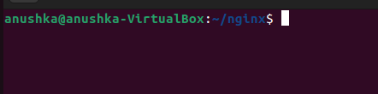
* Switch to that directory and create a file named docker-compose.yaml
* Use docker-compose version 2 to create docker-compose.yaml file.

Create a service named "databases". Use image named "mysql"

Map container 3306 port to host machine 3306 port.

Add environment variables named "MYSQL_ROOT_PASSWORD", "MYSQL_DATABASE", "MYSQL_USER" and "MYSQL_PASSWORD" along with corresponding values for all.

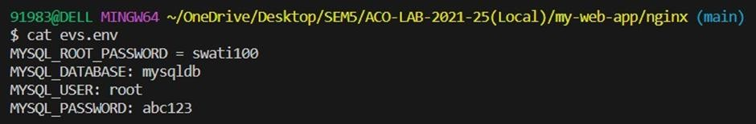

**Running images using docker-compose**

* Save docker-compose.yaml file and do docker-compose up.

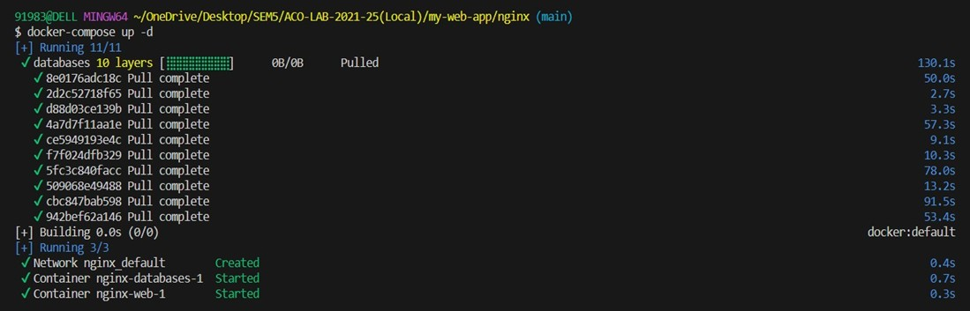

* Verify nginx service is up and is accessible on machine.

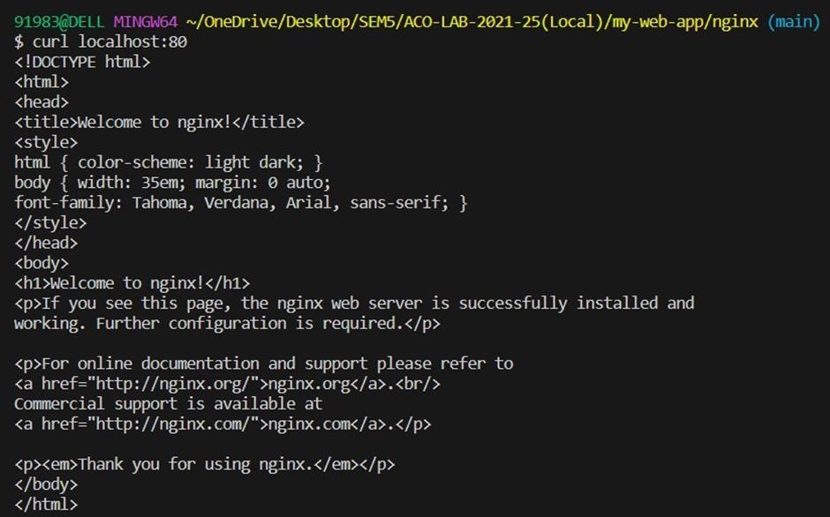

Stop and remove your docker container using docker-compose.



